本实例演示如何添加工具栏（toolbar）到数据网格（datagrid）。  
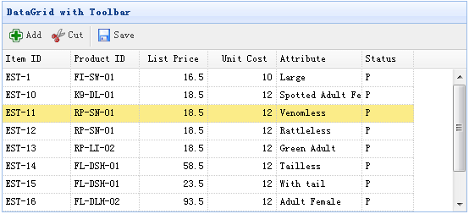

#### 创建数据网格（DataGrid）

    <table id="tt" class="easyui-datagrid" style="width:600px;height:250px"

            url="data/datagrid_data.json"

            title="DataGrid with Toolbar"

iconCls="icon-save"

            toolbar="#tb">

        <thead>

            <tr>

                <th field="itemid" width="80">Item ID</th>

                <th field="productid" width="80">Product ID</th>

                <th field="listprice" width="80" align="right">List Price</th>

                <th field="unitcost" width="80" align="right">Unit Cost</th>

                <th field="attr1" width="150">Attribute</th>

                <th field="status" width="60" align="center">Stauts</th>

            </tr>

        </thead>

    </table>

    <div id="tb">

        <a href="#" class="easyui-linkbutton" iconCls="icon-add" plain="true" onclick="javascript:alert('Add')">Add</a>

        <a href="#" class="easyui-linkbutton" iconCls="icon-cut" plain="true" onclick="javascript:alert('Cut')">Cut</a>

        <a href="#" class="easyui-linkbutton" iconCls="icon-save" plain="true" onclick="javascript:alert('Save')">Save</a>

    </div>